Challah Recipe
Ingredients:
¾ cup water
¼ cup oil
¼ cup honey
1 egg and 1 egg separated
1 ½ tsp salt
2 ½ tsp yeast (or 1 packet)
Approximately 3 cups flour
*Makes two loaves

Directions:
- Heat water, oil and honey until just before it boils.
- Mix 1 ½ cups of flour with yeast and salt.
- Mix liquid into flour mixture.
- Add 1 egg plus yolk from the other, then continue adding flour ½ cup at a time until it becomes doughy, but not sticky.
- Knead dough for about 10 minutes.
- Cover bowl let rise in warm place for about 2 hours.
- Divide dough in half, divide each half into three pieces, roll each piece into a “snake” and braid three snakes to form each Challah. Let rise for another hour
- Then bake at 320 for 20 min.
- Brush with egg-white and bake for another 5 minutes.

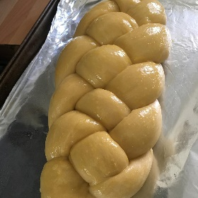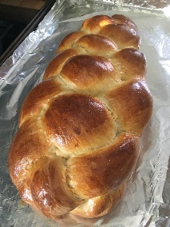

Shabbat Blessings

Blessing over the candles:

בָּרוּך אַתָּה ה׳ אֱלֹהֵינוּ מֶלֶך הָעוֹלָם אַשֶׁר קִדְשָׁנוּ בְּמִצְוֹתָיו וְצִוָנוּ לְהַדְלִיק נֵר שֶל שַבָּת
Baruch ata Adonai, Eloheinu Melech ha-olam, asher kidshanu b’mitzvotav vitzivanu l’hadlik ner shel Shabbat.
Blessed are You, God, Ruler of the universe, who sanctified us with the commandment of lighting Shabbat candles.
Kiddush – Blessing over the wine/grape juice:
בָּרוּךְ אַתָּה ה׳ אֱלֹהֵינוּ מֶלֶךְ הָעוֹלָם בּוֹרֵא פְּרִי הַגָּפֶן
Baruch ata Adonai, Eloheinu melech ha-olam, borei p’ri hagafen.

Blessed are you, God, Ruler of the Universe, who creates the fruit of the vine.

Hamotzi – Blessing over the challah:

בָּרוּך אַתָּה ה׳ אֱלֹהֵינוּ מֶלֶך הָעוֹלָם הָמוֹצִיא לֶחֶם מִן הַאָרֶץ
Baruch ata Adonai, Eloheinu Melech ha-olam, hamotzi lechem min ha’aretz.
Blessed are You, God, Ruler of the universe, who has brought forth bread from the earth.

